Date 17/12/2024
Bigger and with novelty:
W&H doubles AEEDC booth and launches a new hygiene product
The world's largest annual scientific conference and exhibition for dentistry, AEEDC, will once again take place in Dubai from February 4 to 6. W&H, an exhibitor from the very beginning, recognises the importance of the region and doubles its exhibition stand. Exclusively and for the first time, a new product will be launched in Dubai.

Region with great potential
‘AEEDC is increasingly becoming a reference event not only for the MEA region, but for the majority of the most important stakeholder in Europe and Asia Pacific. Furthermore, the Middle East is a fast-growing region with great potential for W&H products. A stronger presence at AEEDC by doubling our existing stand space for the presentation of our products clearly shows how committed we are to the target to be a key player in this region,’ says Angelo Bonzi, Sales Director for EMEA, summarising the strategic decision behind the booth concept and the expansion. W&H anticipates significant growth in the entire dental industry in the region.

Exclusive launch of new product
An exclusive new product awaits visitors this year in Hall 8, booth 8C06. For the first time, the medical technology manufacturer has chosen the AEEDC as the launch location for a new product in the hygiene and sterilization sector. ‘The new W&H product is definitely a miracle of space and fits perfectly to Dubai, the city of superlatives. During development, we focused on optimising daily activities in dental practices. Thanks to additional capacity, combined with W&H ease of use and reliability we can offer an ideal solution to our customers,’ emphasises Alberto Borghi, Product Manager at W&H Sterilization S.r.l. From 4 to 6 February, AEEDC visitors can get advice from our W&H experts and experience the new product live.

Picture 1: WH_ Booth at AEEDC

Caption: W&H doubles its exhibition stand at the AEEDC in Dubai.

© Okapi Advertising L.L.C

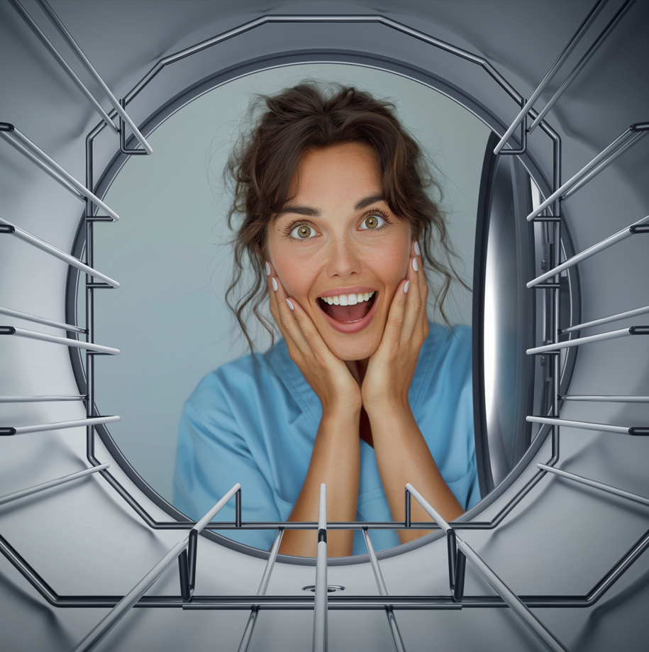 | Picture 2: WH_ New product  Caption: W&H launches a product at the AEEDC for the first time.  © W&H
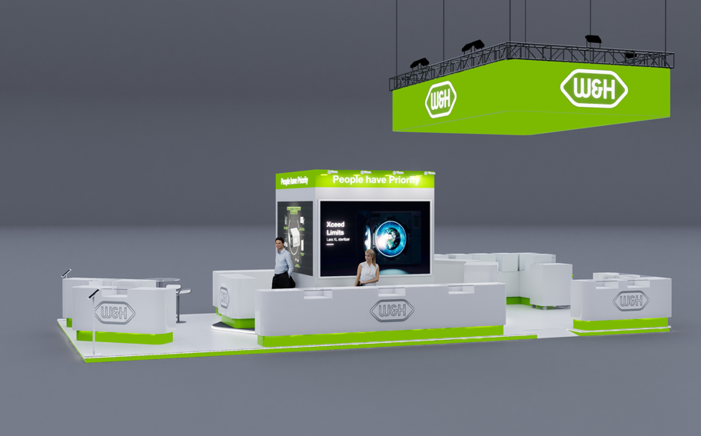
Words: 302
Characters (including spaces): 1,852

Enquiries and contact
Sarah Eder, BA
Corporate Communication Manager
Tel.: +43 664 780 25 480
E-Mail: sarah.eder@wh.com

W&H Dentalwerk Bürmoos GmbH
Ignaz-Glaser-Straße 53, Postfach 1
5111 Bürmoos
Austria

About W&H
Headquartered in Bürmoos, Austria, the international W&H Group is a global leader in the development and manufacture of medical technology products. Passion and innovation are the motor of the company. High-quality product and service solutions, a modern corporate structure, a strong focus on research and development as well as social responsibility make W&H a locally and globally successful family business. About 1,300 employees contribute to the production of hardware and software products for use in the dental, medical and veterinary industries.

